ACTIVIDAD 01. According to next images try to complete the sentences below using: IN, ON, AT.

Observe algunas explicaciones en: http://www.youtube.com/watch?v=4mKTA8i_BP8
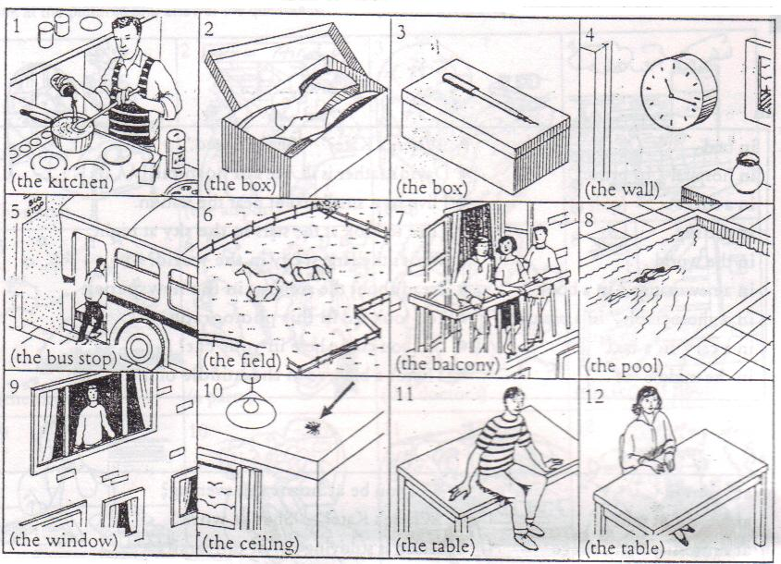

- Where is he? Dónde está él? In the kitchen

Se puede observar en este ejemplo que la opción que hay en el paréntesis es (the kitchen): la cocina. De igual manera cada cuadro tiene su opción; es necesario agregar la preposición adecuada, en este caso se emplea IN porque está en o dentro de la cocina.

- Where are the shoes? Dónde están los zapatos? _________________
- Whre is the pen? Dónde está el lapicero? _________________
- Where is the clock? Dónde está el reloj? _________________
- Where is the bus? Dónde está el bus? _________________
- Where are the horses? Dónde están los caballos? _________________
- Where are they standing? Dónde están ellos parados? _________________
- Where is she swimming? Dónde está ella nadando? _________________
- Where is he standing? Dónde está él parado? _________________
- Where is the spider? Dónde está la araña? _________________
- Where is he sitting? Dónde está él sentándose? _________________
- Where is she sitting? Dónde está ella sentándose? _________________

ACTIVIDAD 02. In next sentences write T (true) or F (false) According to the location and description of each part of the city.
Translate into Spanish.
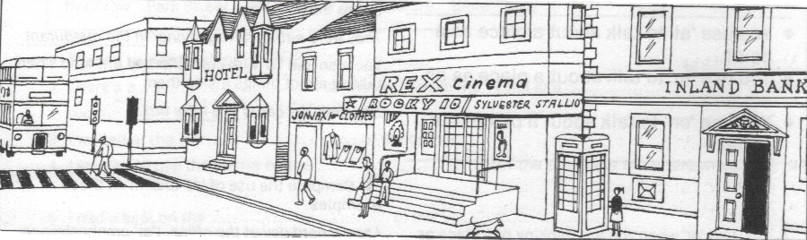
- The cinema is next to the bank _____

- The cinema is next to the bank and the hotel _____

- The boy is behind his mother _____

- The cinema is at the right side of the bank _____

- The traffic light is in front of the bank _____

- The woman is outside the cinema _____

- The bus is near the public telephone _____

- The dog is inside the bank _____

ACTIVIDAD 3. In next link identify the parts of the city that you like or dislike most:

http://www.youtube.com/watch?v=z3mopjueqps
Likes | Dislikes
Park | Gas station

